

# UNIVERSITY OF PETROLEUM AND ENERGY STUDIES

# Assignment 1

1. **Discuss the term Machine Learning.**
2. **Give a brief history of ML.**
3. **How is Artificial Intelligence related to Machine learning and Deep learning? Explain it by giving the block diagram related to these three concepts.**
4. **Discuss and differentiate: Supervised Leaning, Unsupervised Learning and Reinforcement Learning.**
5. **Write a detailed note on the “Classification” in Machine Learning. Take your own day-to-day examples to explain different types of predictive models of Classification in machine learning.**
6. **Give a sketch of the development of Computers, starting from first generation of Computers to the latest one.**
7. **How would you compare a human with a machine like Computers in terms of speed, accuracy and precision? Take your own example for explaining the clock speed of computers and of a human.**



# UNIVERSITY OF PETROLEUM AND ENERGY STUDIES

**Assignment 2**

1. **Discuss linear regression by taking a suitable example of your own. Support your answer with a full explanation by providing suitable Python code and taking a dataset of your own choice.**
2. **Discuss logistic regression by taking a suitable example of your own. Support your answer with a full explanation by providing suitable Python code and taking a dataset of your own choice.**
3. **Differentiate between logistic regression and linear regression. Support your answer with a full explanation by providing suitable Python code and taking a dataset of your own choice.**



# UNIVERSITY OF PETROLEUM AND ENERGY STUDIES

**Assignment 3**

1. **Explain decision tree terminology.**
2. **How does the Decision Tree algorithm work for classification?**
3. 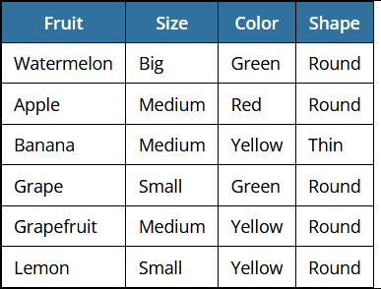**In the below mini-dataset, the label we‘re trying to predict is the type of fruit. This is based off the size, color, and shape variables.**

#### **Calculate the information gained if we select the color variable.**

1. **Calculate the information gained if we select the size variable.**

#### **Calculate the information gained if we select the shape variable.**

#### **Consider the following data set for a binary class problem.**

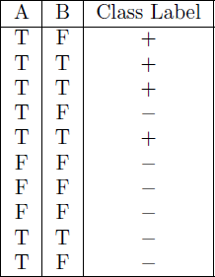

1. **Calculate the Information Gain while splitting A on B. Which attribute would the decision tree induction algorithm should choose?**
2. **Calculate the Gini Index while splitting A on B. Which attribute would the decision tree induction algorithm should choose?**
3. **How does the random forest tree work for classification? Support your answer with a full explanation by providing suitable Python code and taking a dataset of your own choice.**
4. **Explain Bagging and Boosting in training random forest tree. Support your answer with a full explanation by providing suitable Python code and taking a dataset of your own choice.**
5. **How Naive Bayes Algorithms works? Support your answer with a full explanation by providing suitable Python code and taking a dataset of your own choice.**
6. **How does the SVM work? Support your answer with a full explanation by providing suitable Python code and taking a dataset of your own choice.**
7. **How does the KNN work? Support your answer with a full explanation by providing suitable Python code and taking a dataset of your own choice.**
8. **How to choose right value for K in KNN?**